**Metaphor/Architecture Specification Template**

|  |  |  |  |
| --- | --- | --- | --- |
| Team | Minmose Software | Date | 21/04/2015 |
| Program | Analizador funcional | Program # | 1 |
| Instructor | Luis Daniel Benavides | Language | Java |

|  |  |
| --- | --- |
| **Design** | Formato operacional, formato funcional y requerimientos del programa. |
| **References** |  |
|  |  |
|  |  |
|  |  |

**Graphical representation of the metaphor**

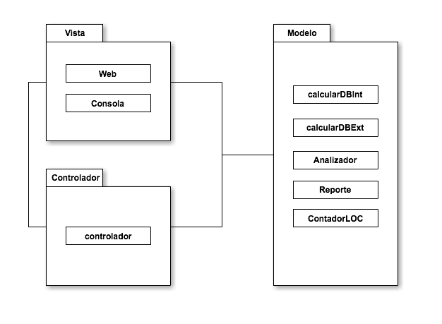

**Textual representation of metaphor**

El diseño está basado en el patrón MVC, de tal manera que las funcionalidades se encuentran en el modelo, donde están los objetos que representan el mundo del proyecto, está el controlador, el cual comunica la vista con el modelo, y por último se encuentra la vista, que es la GUI, donde se tiene una vista de texto por consola, y una vista web, apoyada en servlets, para desplegar en Heroku.

Metaphor/Architecture Specification Template Instructions

|  |  |
| --- | --- |
| Purpose | * To contain the metaphor for a program, component, or system * To enable precise, rapid and complete design understanding * To facilitate thorough design and implementation reviews and inspections |
| General | * Use this template to document the program’s high-level metaphor. * The metaphor could be based in common programming patterns as MVC, or architectural styles as tree layer design, client-server, or inversion of control frameworks * After implementation and testing, update the template to reflect the actual implemented product. * Use plain language and avoid using programming instructions wherever practical. |
| Header | * Enter your name and the date. * Enter the program name and number. * Enter the instructor’s name and the programming language you are using. |
| Design References | List the references used to produce the program’s logical design.   * the Operational, Functional, and State templates * the program’s requirements * any other pertinent source |
| Graphical representation of the metaphor/Architecture | * Create a graphical representation of the main program parts and its interactions * Use clear names for each part * Use edges with arrows to show interactions * Use descriptive names for the interactions |
| Textual representation of metaphor | * Use text to describe the main idea and metaphor used in your design * Describe the graphical representation using common language |